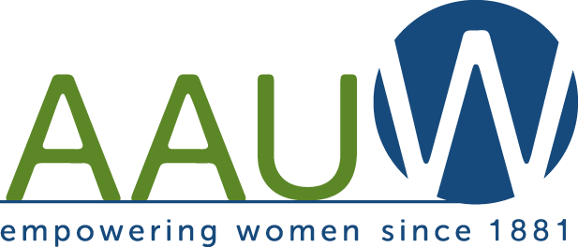
AAUW FARGO-MOORHEAD BRANCH
April 2013
ANNUAL USED BOOK SALE
Our branches’ only fundraiser is being held Fri. April 12 and Sat. April 13 at the Moorhead Center Mall in an empty store space just south of the City Hall Entrance. Please bring your used books April 8-11 3pm-7pm and help spread the word about the sale. Our coffers are low at this time and we are in need of some funds!
April 15 AAUW BRANCH MEETING
The April AAUW meeting will be held at the Fargo Fry'n Pan at 5:30pm. Marion Pressia will discuss Extreme Measures: A Woman’s Self Defense Program. The business meeting will include a report on the book sale and completing the Strategic Plan. (A reprint of the goals and objectives are listed below. The greeter for the evening is Sara Lindberg and Maureen Kelly Jonason will present a current event item related to AAUW’s mission and theme.
The EXECUTIVE COMMITTEE will meet at 10am on Saturday, April 27, at Atomic Coffee in downtown Fargo. This meeting is open to all members.
STRATEGIC PLANNING
The Strategic Planning committee began work on the Strategic Plan in November and identified the following goals and objectives. Our final step is to decide which activities our branch should complete to meet these objectives. The activities may be small steps, such as informing others about AAUW issues, or more detailed activities that we would focus on throughout the year.
Please read over the objectives and be thinking of activities that our Branch might be interested in carrying out during the next two years.
GOAL #1: MEMBERSHIP
*Attract and maintain an involved and diverse membership
*Revitalize Branch meetings to increase membership and attendance
GOAL #2: MISSION-BASED EDUCATION AND PROGRAMS
*Support STEM projects
*Develop programs on current and past women’s issues
*Develop and share programs on pay equity

GOAL #3: PHILANTHROPY
*Identify areas of philanthropic needs
* Develop new fundraising to support initiatives
GOAL #4: RESEARCH
*Promote research provided by National AAUW
*Disseminate research to appropriate audiences
*Collaborate with local organizations who have a shared mission
GOAL #5: ADVOCACY
*Advocate for pay equity for women
*Promote freedom from violence against women
ELECTION OF OFFICERS will be held at the May meeting. We still need someone to fill the Secretary position. Please volunteer by indicating your interest to any board member. If you are asked to serve, please agree!
Someone is also needed to fill the ND state position of Treasurer. Contact Maureen Kelly Jonason, ND State president, if you are interested in this position.
PLAN TO ATTEND!
ND AAUW Annual Meeting is scheduled for Friday Evening and Saturday, April 19 & 20 in Grand Forks. The theme of the Annual Meeting is Fire Up, AAUW! If you would like to car-pool, contact Bobbe at 235-6534.
MN AAUW Annual Convention will meet in Rochester on April 26-27th
Minnesota’s theme is Women’s Health, Women’s Wisdom.
Information about registering for either the ND annual meeting or the MN convention was sent to you earlier. If you need another copy of this information, contact Bobbe. Our Branch will be hosting the ND Annual Membership meeting in 2014 and this will be a good opportunity to gain information on what will be needed as we plan for it.
February Executive Committee Meeting Minutes (missed in March issue)
AAUW Fargo Branch Executive Meeting
Saturday, February 23, 2013
Attending: Roberta, Lucia, Mary, Beth and Laurie

- The March meeting will be held at the Fargo Health Center at 5:30 pm on Monday, March 18, 2018. We will begin with a tour of the center and hold the meeting after. People who would like to have a ride to the Health center and call Roberta and we will pick you up and return you to the Fryin’ Pan.
- The strategic plan will be discussed at the April meeting. We will divide into small groups to brainstorm ideas. It is planned to spend 5 minutes on each strategic area in the groups and then present the ideas to the membership to agree on the strongest idea.
- Officer nominations: President Elect – Laurie Wigtil, Secretary -? , and Membership - ?.
- The book sale will be held on Friday, April 12 and Saturday, April 13 at the Holiday Mall. We will be sorting books Saturday through Thursday, April 6-10. There will be a volunteer sheet past at the March meeting. Prices of books are: hardcover - $2 and paperback - $1. All books will go to half price on Saturday.
We need people to serve on the general committee, people to work the event and places to store books. Beth will pass sign-up sheets around at the March meeting.

Respectfully submitted,
Laurie Wigtil

